- Research: Remove Exploring…technologies- the line below.
- Make 2 Banners: Core Research Pillars for DEAR Lab and another Collaborative Research at DEAR Lab.
- OVERVIEW not required. Instead Put a Picture that summarizes the overview.
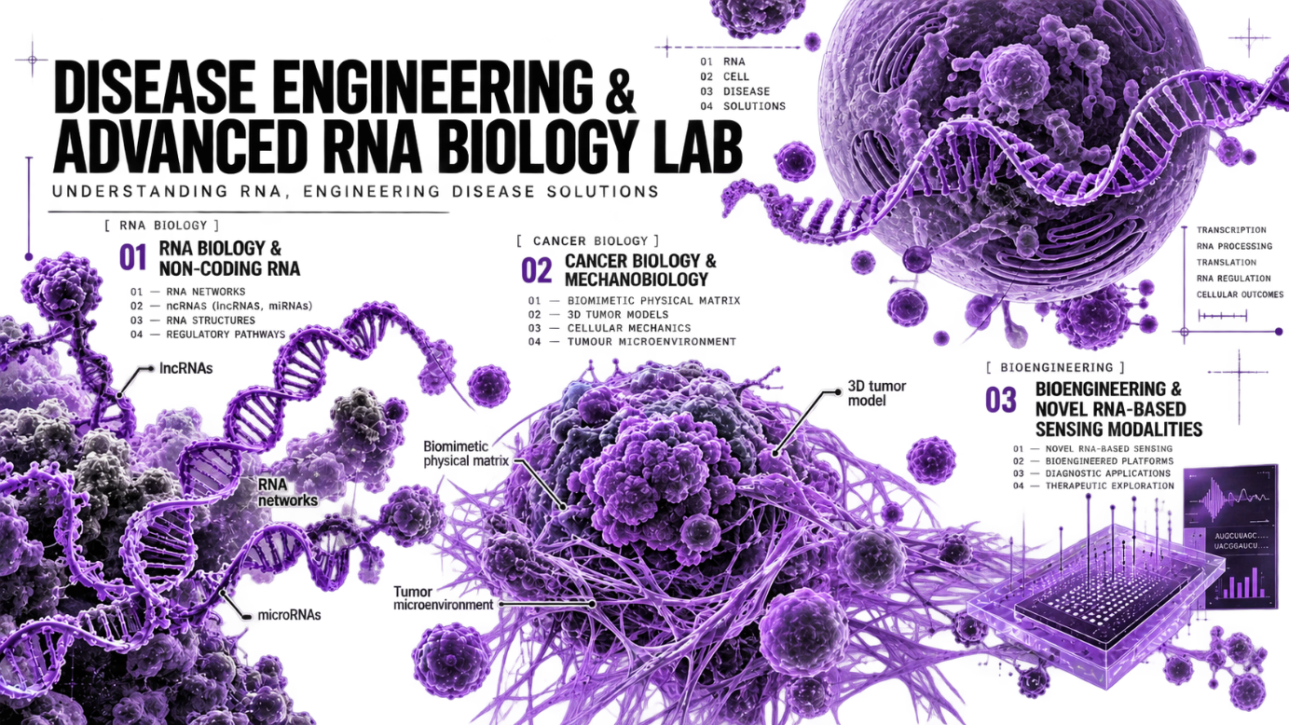

- Under each Core Pillar mentioned, Keywords not required. Remove them.

- Core Pillar 1: LncRNA and miRNAs in Cancer

We investigate the diverse roles of long non-coding RNAs and microRNAs in cancer, focusing on how they regulate gene expression, cellular plasticity, tumour progression, and therapy resistance. Our special focus includes MALAT1, NEAT1, MEG3, HOTAIR, H19, and miR-21, with the aim of deciphering their regulatory networks and identifying RNA-driven vulnerabilities that can be therapeutically explored.
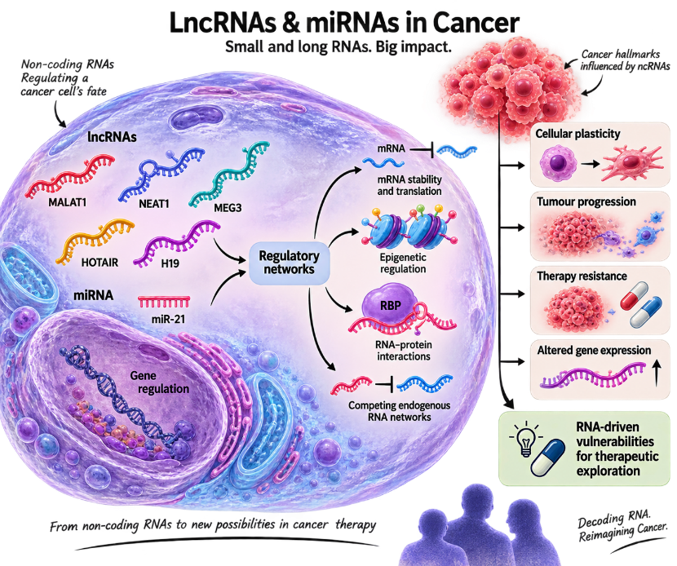

- Core Pillar 2: Understanding key RNA-mRNA pairs and RNP interactions

We seek to understand how RNA molecules interact with mRNAs and RNA-binding proteins (RBPs) to establish complex regulatory networks governing cellular function and disease. A particular focus of our work is the relationship between RNA secondary structures and RNP formation, exploring how structural features of RNA influence molecular interactions, RNA fate, and downstream cellular responses.
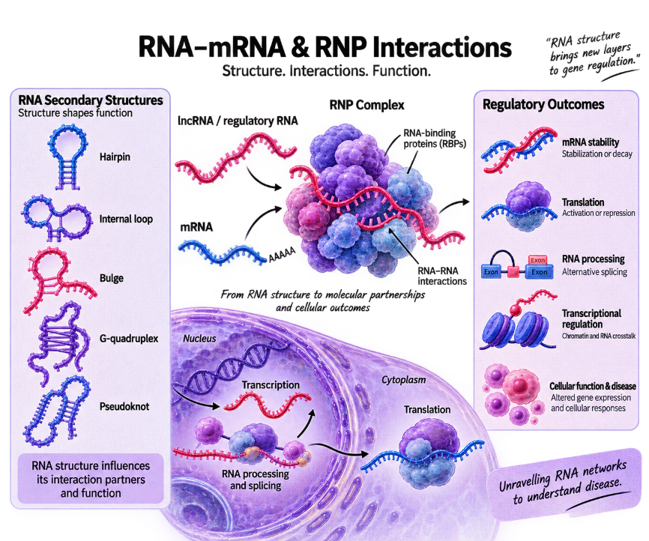

- Core Pillar 3: Mechano-sensing non-coding RNAs
The intersection of mechanobiology and RNA biology remains a largely unexplored frontier. We investigate how mechanical cues from the tumour microenvironment—including matrix stiffness, cellular forces, and mechanical stress—regulate non-coding RNAs. A key emphasis of our research is to discover and unravel mechano-sensing lncRNAs and understand how these previously underexplored RNA-mediated mechanisms enable cancer cells to sense, adapt to, and respond to their physical environment.

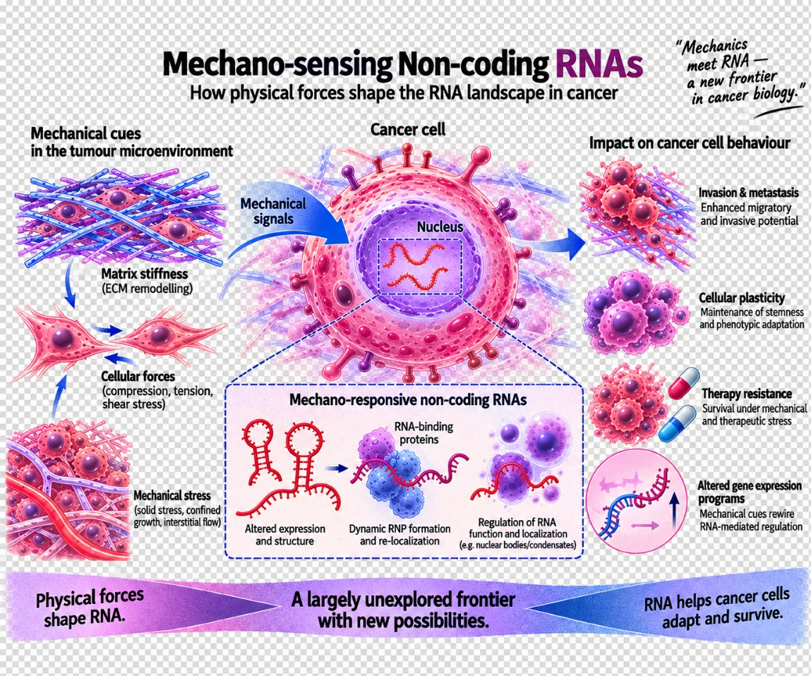

- Core Pillar 4: Disease modelling
We develop tumoroid and organoid models of specific cancer types to recreate key features of the tumour microenvironment in physiologically relevant systems. These models enable us to investigate cancer-specific mechanisms, cellular interactions, RNA regulation, disease progression, and therapeutic responses, while providing a platform to bridge fundamental discoveries with translational applications
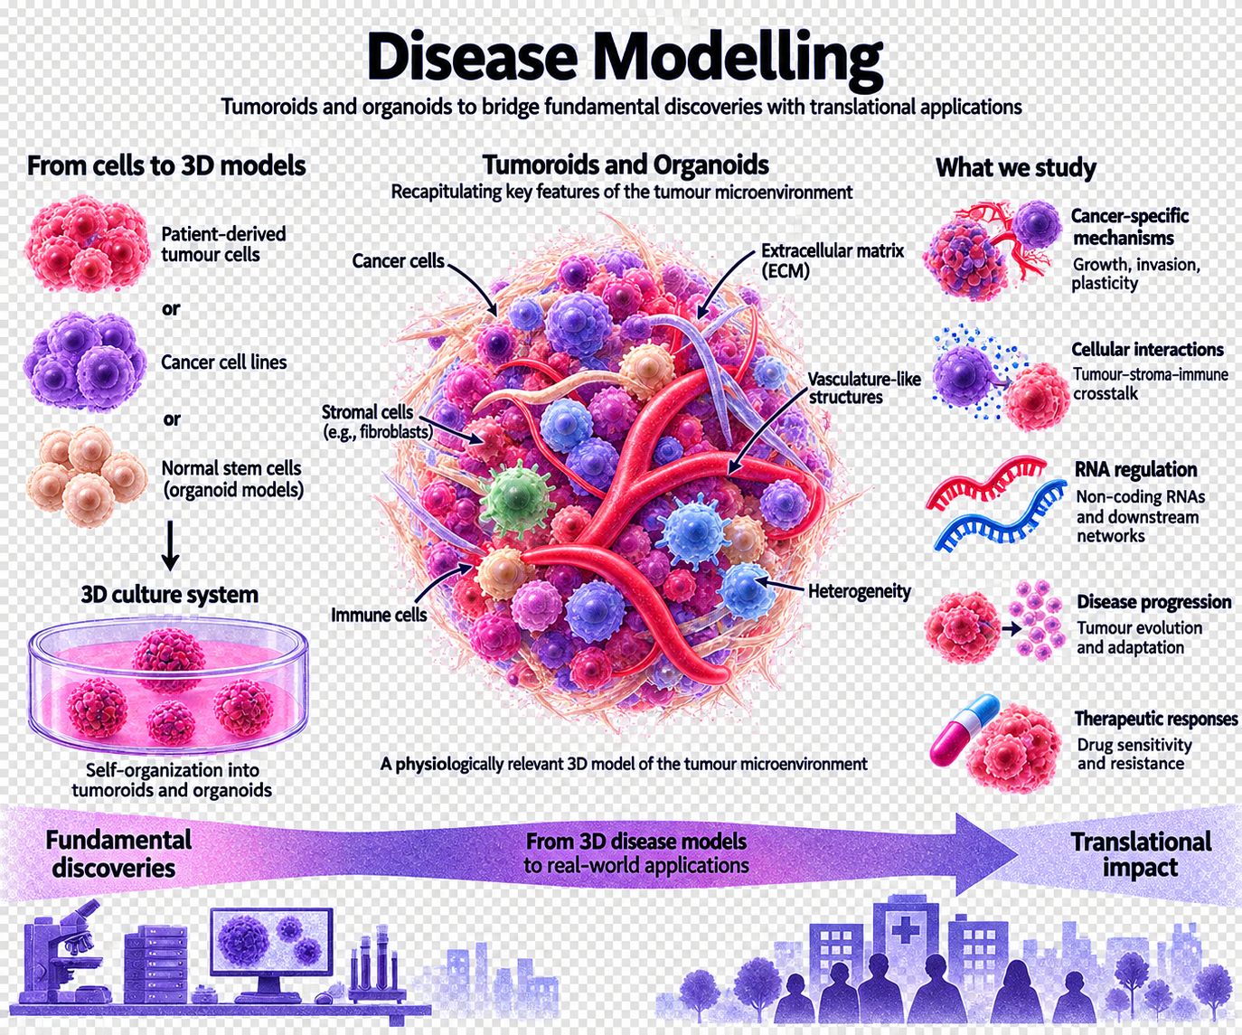

- Under Collaborative Research Banner:

- Prof. Abhijit Majumder, Dept. of Chemical Engineering, IIT Bombay: Mechano-sensing and Cancer Resistance
- Prof. Kasturi Saha, Dept. of Electrical Engineering, IIT Bombay: 1. Nitrogen-vacancy (NV) nanodiamonds (NDs) based quantum biosensing to detect cancer resistance. 2. NV-ND tagged lncRNA probes to detect structural shifts in cancer progression.
- Prof. Mohit Kumar Jolly, Centre for BioSystems Science and Engineering, IISc Bangalore: Mechano-sensing lncRNA transcriptomics study in Glioblastoma.
- Dr. Gollapalli Pavan, Dept. of Bioinformatics and Biostatistics: Pan-Cancer single cell transcriptomics to decipher cell population specific effects in Glioblastoma.
- Prof. Archa Fox, University of Western Australia (UWA), Medical School, UWA Centre for Medical Research, School of Human Sciences, Australian Centre for RNA Therapeutics in Cancer: Mechano-sensing NEAT1 lncRNA and paraspeckle biology in Glioblastoma.
- Prof. Kalicharan Sharma, Dept. Pharmaceutical Chemistry and Analysis, ISF College of Pharmacy, Moga and Dr. Gunimala Chakraborty, Dept. of Molecular Genetics and Cancer, NUCSER, Nitte DU: Small molecule based therapeutic targeting to block angiogenesis in Breast Cancer.
- Prof. Anirban Chakraborty, Dept. of Molecular Genetics and Cancer, NUCSER, Nitte DU and Prof. Shubha Gopal, Dept of Studies in Microbiology, University of Mysore: Tumoroid and Microbe interactions.
- Dr. Nandini Verma, ACTREC: LncRNAs in Breast cancer.






Put Research Collaboration Logos:


- Make one Funding Section:
“DEAR Lab funding is from:”
And only Put Logos:





11. REMOVE THIS FROM RESEARCH TAB : 

